RAJALAKSHMI ENGINEERING COLLEGE

.

**Dept of Artificial Intelligence and Machine Learning** | **Rajalakshmi Engineering College**

1

# RAJALAKSHMI NAGAR, THANDALAM – 602 105



|  |
| --- |
| **CS23221**  **PYTHON PROGRAMMING LAB** |
| **Laboratory Observation Note Book** |

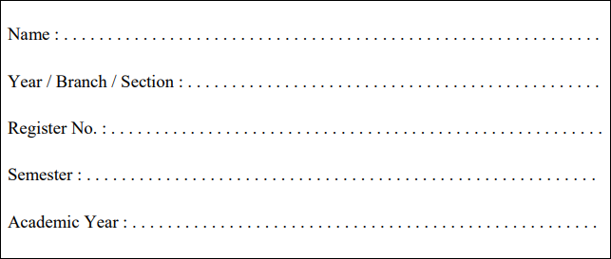

**Dinesh Karthik K**

2023/AIML/A

231501042

2nd Semester

2023-2024

**INDEX**

.

**Dept of Artificial Intelligence and Machine Learning** | **Rajalakshmi Engineering College**

2

**Reg. No : 231501042 Name: Dinesh Karthik K**

**Year: Ist Year Branch: AIML Sec: A**

|  |  |  |  |  |
| --- | --- | --- | --- | --- |
| **S.**  **No.** | **Date** | **Title** | **Page No.** | **Teacher’s Signature / Remarks** |
| **Introduction to python-Variables-Datatypes-Input/Output-Formatting** | | | | |
| 1.1 | 2/3/24 | Converting Input Strings | **7** |  |
| 1.2 | 2/3/24 | Gross salary | **8** |  |
| 1.3 | 2/3/24 | Square Root | **9** |  |
| 1.4 | 2/3/24 | Gain percent | **10** |  |
| 1.5 | 2/3/24 | Deposits | **1**2 |  |
| 1.6 | 2/3/24 | Carpenter | **1**3 |  |
| **Operators in Python** | | | | |
| 2.1 | 9/3/24 | Widgets and Gizmos | **1**5 |  |
| 2.2 | 9/3/24 | Doll Sings | **1**6 |  |
| 2.3 | 9/3/24 | Birthday party | **1**7 |  |
| 2.4 | 9/3/24 | Hamming Weight | **1**9 |  |
| 2.5 | 9/3/24 | Compound Interest | **2**0 |  |
| 2.6 | 9/3/24 | Eligible to donate blood | **2**1 |  |
| 2.7 | 9/3/24 | C or D | **2**2 |  |
| 2.8 | 9/3/24 | Troy Battle | **2**3 |  |
| 2.9 | 9/3/24 | Tax and Tip | **2**4 |  |
| 2.10 | 9/3/24 | Return last digit of the given number | **2**5 |  |
| **Selection Structures in Python** | | | | |
| 3.1 | 16/3/24 | Admission eligibility | **2**7 |  |
| 3.2 | 16/3/24 | Classifying triangles | **2**9 |  |
| 3.3 | 16/3/24 | Electricity Bill | **3**0 |  |
| 3.4 | 16/3/24 | IN/OUT | **3**2 |  |
| 3.5 | 16/3/24 | Vowel or Constant | **3**4 |  |
| 3.6 | 16/3/24 | Leap Year | **3**6 |  |
| 3.7 | 16/3/24 | Month name to Days | **3**7 |  |
| 3.8 | 16/3/24 | Pythagorean triple | **3**9 |  |
| 3.9 | 16/3/24 | Second Last Digit | **4**0 |  |

|  |  |  |  |  |
| --- | --- | --- | --- | --- |
| 3.10 | 16/3/24 | Chinese Zodiac | **4**1 |  |
| **Algorithmic Approach: Iteration Control Structures** | | | | |
| 4.1 | 30/3/24 | Factors of a Number | **4**4 |  |
| 4.2 | 30/3/24 | Non-Repeated Digits Count | **4**5 |  |
| 4.3 | 30/3/24 | Prime Checking | **4**7 |  |
| 4.4 | 30/3/24 | Next Perfect Square | **4**8 |  |
| 4.5 | 30/3/24 | Nth Fibonacci | **4**9 |  |
| 4.6 | 30/3/24 | Disarium Number | **5**0 |  |
| 4.7 | 30/3/24 | Sum of Seriesv | **5**2 |  |
| 4.8 | 30/3/24 | Unique Digits Count | **5**4 |  |
| 4.9 | 30/3/24 | Product of single digits | **5**5 |  |
| 4.10 | 30/3/24 | Perfect Square After adding One | **5**6 |  |
| **List in Python** | | | | |
| 5.1 | 6/4/24 | Monotonic array | **5**8 |  |
| 5.2 | 6/4/24 | Check pair with difference k . | **6**0 |  |
| 5.3 | 6/4/24 | Count Elements | **6**2 |  |
| 5.4 | 6/4/24 | Distinct Elements in an Array | **6**4 |  |
| 5.5 | 6/4/24 | Element Insertion | **6**5 |  |
| 5.6 | 6/4/24 | Find the Factor | **67** |  |
| 5.7 | 6/4/24 | Merge list | **69** |  |
| 5.8 | 6/4/24 | Merge Two Sorted Arrays Without  Duplication | **70** |  |
| 5.9 | 6/4/24 | Print Element Location | **72** |  |
| 5.10 | 6/4/24 | Strictly increasing | **74** |  |
| **Strings in Python** | | | | |
| 6.1 | 13/4/24 | Count chars | **76** |  |
| 6.2 | 13/4/24 | Decompress the String | **77** |  |
| 6.3 | 13/4/24 | First N Common Characters | **78** |  |
| 6.4 | 13/4/24 | Remove Characters | **79** |  |
| 6.5 | 13/4/24 | Remove Palindrome Words | **80** |  |
| 6.6 | 13/4/24 | Return Second Word in Uppercase | **81** |  |
| 6.7 | 13/4/24 | Reverse String | **82** |  |
| 6.8 | 13/4/24 | String characters balance Test | **83** |  |
| 6.9 | 13/4/24 | Unique Names | **84** |  |
| 6.10 | 13/4/24 | Username Domain Extension | **85** |  |
| **Functions** | | | | |

.

**Dept of Artificial Intelligence and Machine Learning** | **Rajalakshmi Engineering College**

3

|  |  |  |  |  |
| --- | --- | --- | --- | --- |
| 7.1 | 20/4/24 | Abundant Number | **87** |  |
| 7.2 | 20/4/24 | Automorphic number or not | **88** |  |
| 7.3 | 20/4/24 | Check Product of Digits | **89** |  |
| 7.4 | 20/4/24 | Christmas Discount | **90** |  |
| 7.5 | 20/4/24 | Coin Change | **91** |  |
| 7.6 | 20/4/24 | Difference Sum | **92** |  |
| 7.7 | 20/4/24 | Ugly number | **93** |  |
| **Tuple & Set** | | | | |
| 8.1 | 27/4/24 | Binary String | **95** |  |
| 8.2 | 27/4/24 | Check Pair | **96** |  |
| 8.3 | 27/4/24 | DNA Sequence | **97** |  |
| 8.4 | 27/4/24 | Print repeated no | **98** |  |
| 8.5 | 27/4/24 | Remove repeated | **99** |  |
| 8.6 | 27/4/24 | malfunctioning keyboard | **100** |  |
| 8.7 | 27/4/24 | American keyboard | **101** |  |
| **Dictionary** | | | | |
| 9.1 | 4/5/24 | Uncommon Words | **104** |  |
| 9.2 | 4/5/24 | Sort Dictionary By Values Summation | **105** |  |
| 9.3 | 4/5/24 | Winner Of Election | **107** |  |
| 9.4 | 4/5/24 | Student Record | **109** |  |
| 9.5 | 4/5/24 | Scramble Score | **111** |  |
| **Searching & Sorting** | | | | |
| 10.1 | 25/5/24 | Merge Sort | **113** |  |
| 10.2 | 25/5/24 | Bubble Sort | **114** |  |
| 10.3 | 25/5/24 | Peak Element | **116** |  |
| 10.4 | 25/5/24 | Binary Search | **117** |  |
| 10.5 | 25/5/24 | Frequency of Numbers | **118** |  |
| **Exceptions** | | | | |
| 11.1 | 1/6/24 | Out of Range Numbers | **121** |  |
| 11.2 | 1/6/24 | Divide by Zero | **121** |  |
| 11.3 | 1/6/24 | Valid Age | **123** |  |
| 11.4 | 1/6/24 | Safe Square Root | **124** |  |
| 11.5 | 1/6/24 | Valid Integer | **125** |  |

.

**Dept of Artificial Intelligence and Machine Learning** | **Rajalakshmi Engineering College**

4

|  |  |  |  |  |
| --- | --- | --- | --- | --- |
| **Modules** | | | | |
| 12.1 | 8/6/24 | Power of 2 | **127** |  |
| 12.2 | 8/6/24 | Square Tiles | **128** |  |
| 12.3 | 8/6/24 | Shoe Size | **129** |  |
| 12.4 | 8/6/24 | Count Unique Pairs | **131** |  |
| 12.5 | 8/6/24 | Calculate Average Marks | **133** |  |

.

**Dept of Artificial Intelligence and Machine Learning** | **Rajalakshmi Engineering College**

5

.

**Dept of Artificial Intelligence and Machine Learning** | **Rajalakshmi Engineering College**

6

**01 - Introduction to Python-Variables-Datatypes Input/Output-Formatting**

**Ex. No. : 1.1 Date: 2/3/24**

.

**Dept of Artificial Intelligence and Machine Learning** | **Rajalakshmi Engineering College**

7

**Register No.: 231501042 Name: Dinesh Karthik K**

# [Converting Input Strings](https://www.rajalakshmicolleges.net/moodle/mod/quiz/view.php?id=6373)

Write a program to convert strings to an integer and float and display its type.

*Sample Input:*

10

10.9

*Sample Output:* 10,<class 'int'> 10.9,<class 'float'>

## For example:

|  |  |
| --- | --- |
| **Input** | **Result** |
| 10  10.9 | 10,<class 'int'> 10.9,<class 'float'> |

**PROGRAM**

b=int(input(""))

c=float(input("")) print("{0},{1}".format(b,type(b)))

print("{:.1f},{}".format(c,type(c)))

# Output:

.

**Dept of Artificial Intelligence and Machine Learning** | **Rajalakshmi Engineering College**

8

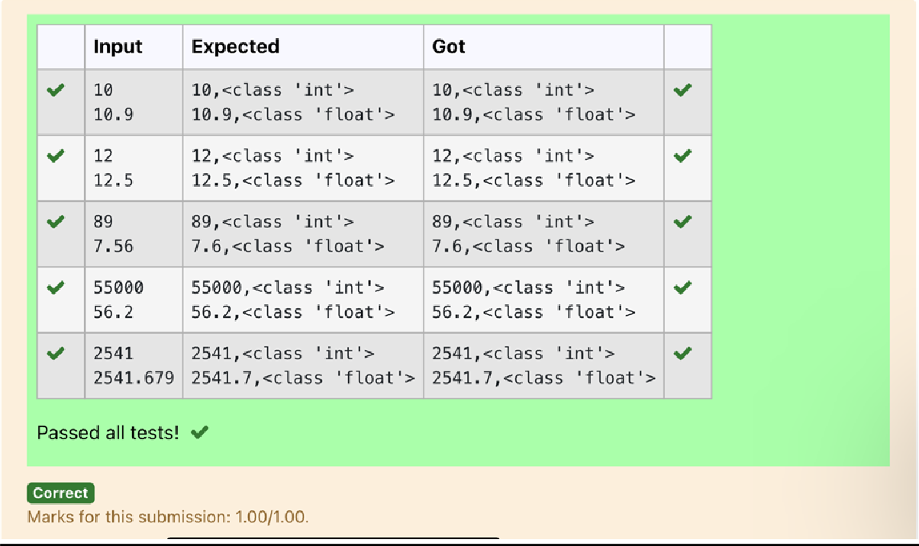

.

**Dept of Artificial Intelligence and Machine Learning** | **Rajalakshmi Engineering College**

9

**Ex. No. : 1.2 Date: 2/3/24**

**Register No.: 231501042 Name: Dinesh Karthik K**

# [Gross Salary](https://www.rajalakshmicolleges.net/moodle/mod/quiz/view.php?id=6374)

Ramesh’s basic salary is input through the keyboard. His dearness allowance is 40% of his basic salary, and his house rent allowance is 20% of his basic salary. Write a program to calculate his gross salary.

*Sample Input:*

10000

*Sample Output:*

16000

## For example:

|  |  |
| --- | --- |
| **Input** | **Result** |
| 10000 | 16000 |

**PROGRAM**

sal=int(input("")) dea=0.40*sal ren=0.20*sal print(round(sal+dea+ren))

# Output:

.

**Dept of Artificial Intelligence and Machine Learning** | **Rajalakshmi Engineering College**

10

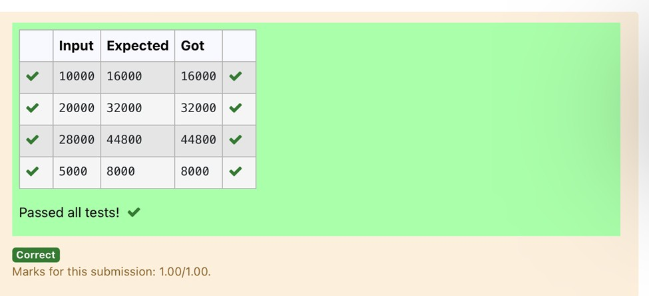

.

**Dept of Artificial Intelligence and Machine Learning** | **Rajalakshmi Engineering College**

11

**Ex. No. : 1.3 Date: 2/3/24**

**Register No.: 231501042 Name: Dinesh Karthik K**

# Square Root

Write a simple python program to find the square root of a given floating point number. The output should be displayed with 3 decimal places.

Sample Input:

8.00

Sample Output:

2.828

## For example:

|  |  |
| --- | --- |
| **Input** | **Result** |
| 14.00 | 3.742 |

**PROGRAM**

from math import sqrt a=float(input()) print("{:.3f}".format(sqrt(a)))

# Output:

.

**Dept of Artificial Intelligence and Machine Learning** | **Rajalakshmi Engineering College**

12

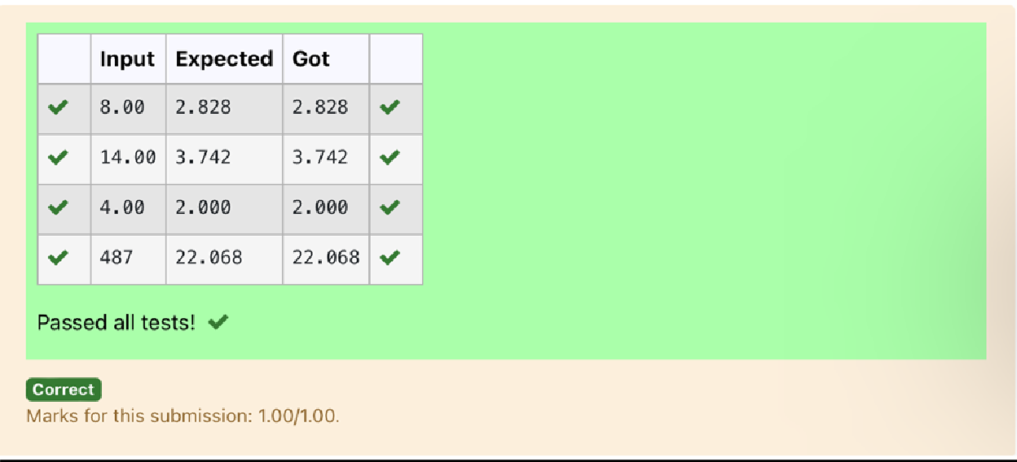

.

**Dept of Artificial Intelligence and Machine Learning** | **Rajalakshmi Engineering College**

13

**Ex. No. : 1.4 Date: 2/3/24**

**Register No.: 231501042 Name: Dinesh Karthik K**

# [Gain percent](https://www.rajalakshmicolleges.net/moodle/mod/quiz/view.php?id=6376)

Alfred buys an old scooter for Rs. X and spends Rs. Y on its repairs. If he sells the scooter for Rs. Z (Z>X+Y). Write a program to help Alfred to find his gain percent. Get all the above-mentioned values through the keyboard and find the gain percent.

Input Format:

The first line contains the Rs X The second line contains Rs Y The third line contains Rs Z

Sample Input:

10000

250

15000

Sample Output:

46.34 is the gain percent.

## For example:

|  |  |
| --- | --- |
| **Input** | **Result** |
| 45500  500  60000 | 30.43 is the gain percent. |

.

**Dept of Artificial Intelligence and Machine Learning** | **Rajalakshmi Engineering College**

14

**PROGRAM**

a=int(input()) b=int(input()) c=int(input()) d=a+b

e=c-d

print("{:.2f} is the gain percent.".format((e/d)*100))

**Output:**

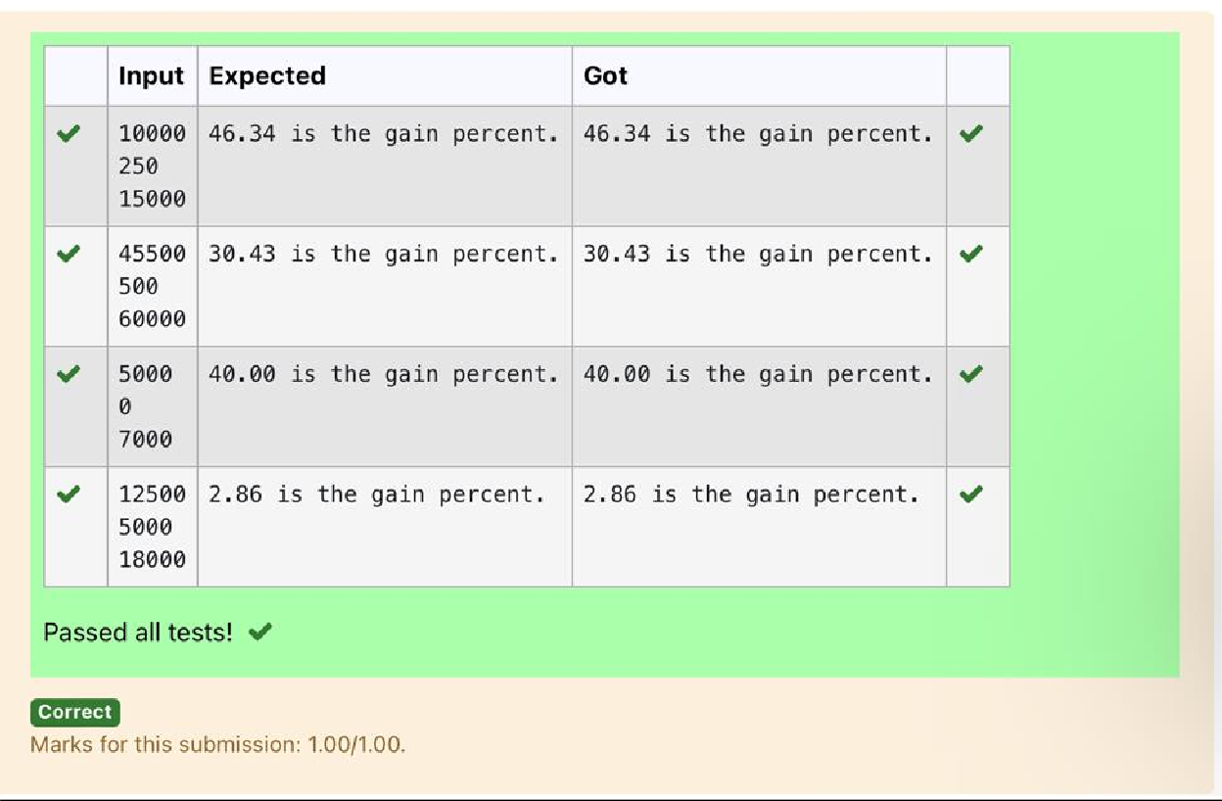

**Ex. No. : 1.5 Date: 2/3/24**

.

**Dept of Artificial Intelligence and Machine Learning** | **Rajalakshmi Engineering College**

15

**Register No.: 231501042 Name: Dinesh Karthik K**

# [Deposits](https://www.rajalakshmicolleges.net/moodle/mod/quiz/view.php?id=6378)

In many jurisdictions, a small deposit is added to drink containers to encourage people to recycle them. In one particular jurisdiction, drink containers holding one liter or less have a $0.10 deposit and drink containers holding more than one liter have a $0.25 deposit. Write a program that reads the number of containers of each size(less and more) from the user. Your program should continue by computing and displaying the refund that will be received for returning those containers. Format the output so that it includes a dollar sign and always displays exactly two decimal places.

Sample Input 10

20

Sample Output

Your total refund will be $6.00.

## For example:

|  |  |
| --- | --- |
| **Input** | **Result** |
| 20  20 | Your total refund will be $7.00. |

**PROGRAM**

a=int(input()) b=int(input()) c=a*0.10 d=b*0.25

print("Your total refund will be ${:.2f}.".format(c+d))

Output:

.

**Dept of Artificial Intelligence and Machine Learning** | **Rajalakshmi Engineering College**

16

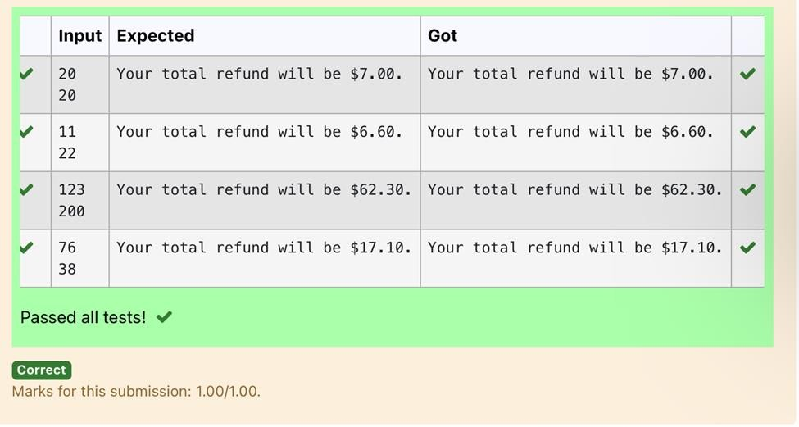

**Dept of Artificial Intelligence and Machine Learning** | **Rajalakshmi Engineering College**

17

**Ex. No. : 1.6 Date: 2/3/24**

**Register No.: 231501042 Name: Dinesh Karthik K**

# [Carpenter](https://www.rajalakshmicolleges.net/moodle/mod/quiz/view.php?id=6379)

Justin is a carpenter who works on an hourly basis. He works in a company where he is paid Rs 50 for an hour on weekdays and Rs 80 for an hour on weekends. He works 10 hrs more on weekdays than weekends. If the salary paid for him is given, write a program to find the number of hours he has worked on weekdays and weekends.

## Hint:

If the final result(hrs) are in -ve convert that to +ve using abs() function

The abs() function returns the absolute value of the given number. number = -20

absolute_number = abs(number) print(absolute_number)

# Output: 20

## Sample Input:

450

## Sample Output:

weekdays 10.38

weekend 0.38

## For example:

|  |  |
| --- | --- |
| **Input** | **Result** |
| 450 | weekdays 10.38  weekend 0.38 |

**PROGRAM**

a=int(input()) b=abs(((a-500)/130))

print("weekdays {:.2f}".format(10+b))

print("weekend {:.2f}".format(b))

.

Output:

.

**Dept of Artificial Intelligence and Machine Learning** | **Rajalakshmi Engineering College**

18

